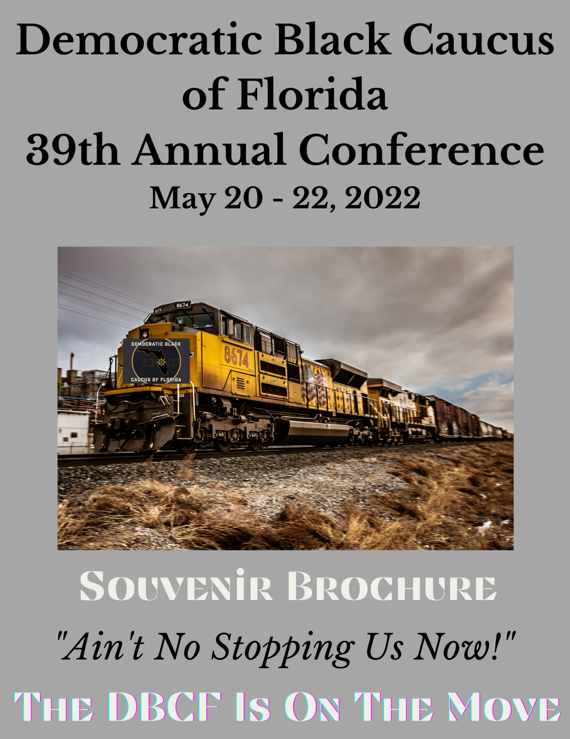

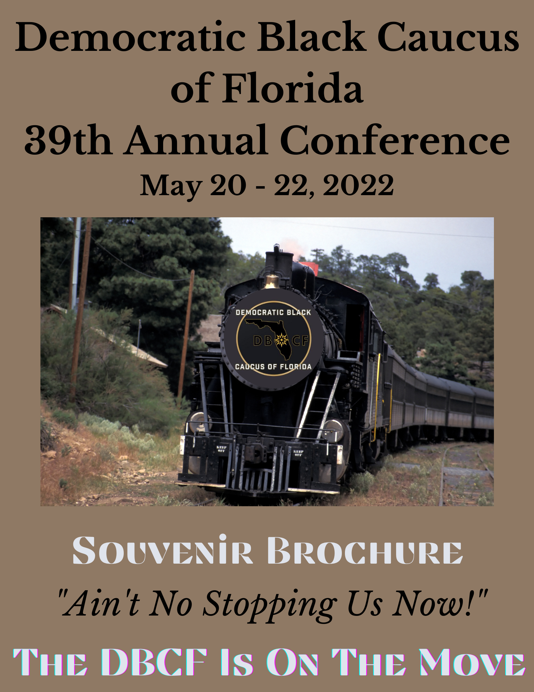

April 18, 2022

STATE OFFICERS
President
Trevor Mallory
1st Vice-President
Jordan Pride
2nd Vice-President
Easton Harrison
Recording Secretary
Annie Gumren-Sweeting
Treasurer
Jill Lewis-Daggs

CONFERENCE COMMITTEE

Com. Renee Flowers
Christina Forrest
Derrick Scott
Jill Lewis-Daggs

Democratic Black Caucus of Florida
Attn: Conference Committee
P.O. Box 2754
Fort Walton Beach, FL 32548
(850) 259-4735
www.dbcflorida.org

Democratic Black Caucus of Florida
P. O. Box 2754
Fort Walton Beach, Florida 32549
Place Address Here
Street
State Zip

Dear ______:

To commemorate our 39th Annual Democratic Black Caucus of Florida State Conference, we are preparing a souvenir booklet. This will be distributed to all attendees.

The conference will be held May 20th – 22nd, 2022, at the magnificent Rosen Centre in Orlando, Florida.

More than 200 guests will be in attendance and this forum will provide an excellent opportunity for you to advertise your business and/or services to a targeted audience, who traditionally support and patronize businesses that show support for the Democratic Black Caucus of Florida.

As a Conference Ad Patron, you will help to support the State and Local Black Caucuses of Florida as we increase voter participation, push a relevant legislative agenda and mobilize community action around our issues.

Our attendees will include a wide demographic base including our members, college students, civic and community leaders, local elected officials, national government leaders, and corporate professionals. The opportunity to introduce your business and/or service to a vast audience is certainly appealing and we ask you to consider advertising with us.

Please review the attached Souvenir Brochure Form for the various advertisement options and submit your ad conveniently via email to: dscott1906@outlook.com and treasurerdbcf@gmail.com.
Remit payment to:
DBCF
Attn: Souvenir Brochure
P.O. Box 2754
Fort Walton Beach, FL 32549

We encourage you to secure your advertisement space early to take advantage of this opportunity.

RE: Specifics for the Souvenir Brochure: Please see Ad Layout Specs Below

May 2, 2022
All ads (pdf format only) to be included in the souvenir booklet, must be received by this date.

*REMINDER- all artwork must be print ready when submitted. Please see ad specs below.

Full Page DBCF Member Ad (8 ½ X 11) $200

Full Page Non-Member Ad (8 ½ X 11) $225

Half Page DBCF Member Ad (8 ½ X 5 ½) $125

Half Page DBCF Non-Member Ad (8 ½ X 5 ½) $150

Outside Back Cover (non-sponsorship ) $500

Inside Back Cover (non-sponsorship) $300

Inside Front Cover (non-sponsorship) $300

Again, thank you. We look forward to an exciting conference!

If you have questions, please feel free to contact Derrick Scott at (917) 334-1590 or email dscott1906@outlook.com.

Sincerely,

Trevor Mallory

Trevor Mallory,
President
Democratic Black Caucus of Florida

